Subject | 1.3 GHz Band - Additional Information
Society | RSGB | Country: | UK
Committee: | C5 | Paper number: | ZL23_C5_19
Author: | Murray Niman G6JYB, RSGB Spectrum Chair

Introduction:
Whilst much focus has understandably been on WRC-23 AI-9.1b regarding amateur radio coexistence with RNSS (Galileo etc), the 1.3GHz band is home to other primary services.

We draw attention to current developments which may assist Member Societies, including the adjacent band where a few countries have national amateur allocations.

Background:
The 1240-1300MHz secondary amateur service allocation has successfully co-existed with high power Primary radars for many years. Indeed these ‘L-Band’ radars have higher priority than RNSS based on ITU RR footnote 5.329 – effectively making them ‘super-primary’.

Adjacent Band Situation:
A few countries have national amateur secondary allocations that extend just beyond the 1240-1300MHz standard range. Usage has been limited to repeater outputs, as they are generally fixed locations and modest ERP which can be easily coordinated with respect to most Primary Radars. Leading examples are:

- UK: 1300-1325 MHz – TV Repeater Outputs (~20 systems), 25W erp
- Ireland: 1300-1304 MHz – Repeater Outputs, 1W pep (into the antenna)

Prior to agenda item AI-9.1b being agreed at WRC-19, there was some short-lived consideration of an alternative proposal to move the amateur service allocation into this frequency range. This was quickly dropped by stakeholders when it was realised it would encounter considerable opposition in ITU studies.

However WRC-19 did agree preliminary WRC-27 Agenda Item 2.7 (based on Resolution 250) for potential Mobile use in the 1300-1350MHz range. As we get close to WRC-23, it is notable that CEPT now strongly oppose this proposal. If dropped, that would open the way for consideration of similar national solutions based on the UK/Ireland examples for modest power fixed repeater outputs that could in principle be coordinated with the radars.

Primary Radar Usage Changes:
Member Societies should also be aware that the existing band is facing growth in L-band (23cm) Primary Radar usage as well. However this need not be a threat. There are two notable drivers for this change:

Windfarms
The reflections from the moving blades cause considerable clutter to radar signal processing. A common solution for long range air-traffic management is to deploy additional L-band radars (as the blades have a lower radar reflectivity/Doppler at L-Band, compared to S-Band).

  Windfarms – some models can be over 100m tall | 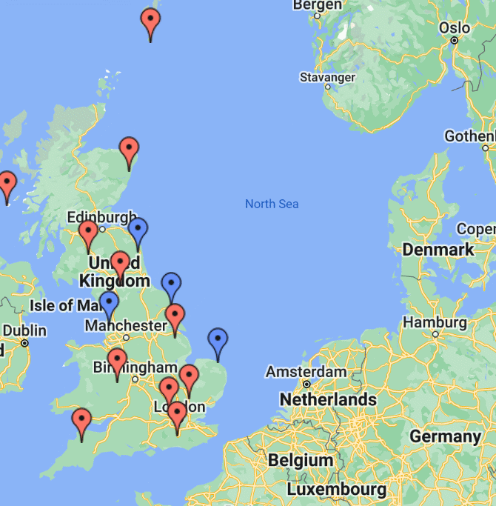  Extra Radars – Blue markers

Airborne Usage
Many airborne S-Band systems are end-of-life and encountering growing interference and clutter from both 4/5G usage in 3.4GHz - as well as Windfarms. Again the solution being adopted by Australia, Turkey, UK, USA, and probably Europe and perhaps others in due course is to move from S-Band down to L-Band, potentially overlapping our secondary 23cm allocation.

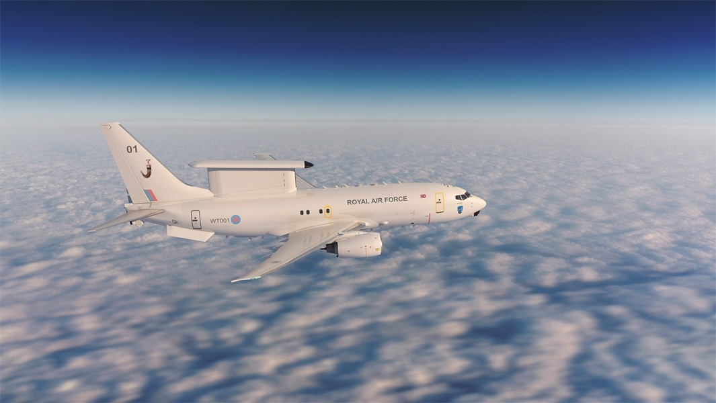  Airborne Radar: New L-Band |   Old / retiring S-Band system

Whilst this can appear to be another challenge, it may increase the protection of L-Band vs any other encroachment such as Mobile or further RNSS expansion. There is no reason we cannot co-exist with these radars as secondary users, as we have done in the past. However it does mean that sharing with declining military use in the 3300-3410MHz (9cm) range, versus potential new Mobile usage may be more problematic.

RSGB hope that this information on 1300MHz+ national allocations and other developments will be useful for other Member Societies.

